Email Subject Line: Press Release - Admix Adds the Rotomaxx™ III and Rotomaxx™ III CX to its Equipment Lineup
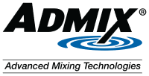

Press Release from Admix, Inc.
FOR IMMEDIATE RELEASE

CONTACT:
Katie Connors
Phone: +1-603-541-9211
Email: kconnors@admix.com

Admix Adds the Rotomaxx™ III and Rotomaxx™ III CX to its Equipment Lineup
Londonderry, NH, August 9, 2023 – Admix, Inc., global manufacturer of hygienic and industrial mixing equipment serving the food/beverage, chemical, cosmetic, and pharmaceutical industries, today announces the long-awaited addition of the Rotomaxx III and Rotomaxx III CX, the high efficiency, slow speed agitator designed for both the chemical/industrial and the hygienic/sanitary industries.

The robust Rotomaxx III and Rotomaxx III CX are designed for the most demanding operating environments for hygienic and chemical applications. The modular design allows for multiple impeller, shaft diameter, gear ratio, and motor horsepower combinations, with robust designs that can handle tank volumes up to approximately 100,000 gallons (378.5 m³).

“We are excited to offer the Rotomaxx III and the Rotomaxx III CX to processors who are looking for truly customizable mixing solutions to their application needs.” said Patrick Lakin, Director of Sales and Marketing, Admix, Inc.

The Rotomaxx III and the Rotomaxx III CX are available to order effective immediately on a worldwide basis directly through Admix and its sales partner channel. For more information visit https://www.admix.com/rotomaxx-iii-agitator or https://www.admix.com/rotomaxx-iii-cx

About Admix, Inc.
Admix is a recognized leader of advanced mixing technologies for the food, beverage, pharmaceutical, cosmetics and chemical industries. Admix offers innovative, customizable, high efficiency agitators and high shear mixing systems, backed with 100+ years of applications expertise that helps processors improve productivity and resolve challenging mixing and blending issues. Admix equipment is specialized for the induction and high-speed dispersion of powders and semi-solids, dissolving, deagglomeration, creating homogenous mixes, building emulsions, particle size reduction and improving product texture and quality. The Admix equipment and services portfolio includes high shear batch and continuous mixers, dispersers, wet milling machines, powder induction and dispersion systems, agitators, static mixers, spare parts, rebuild kits, and field service programs. Admix, Inc. US headquarters is in New Hampshire and Europe headquarters is in Denmark, operating as Admix Europe ApS.
###

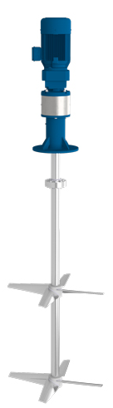

Button – Download Hi-Res Image
Button – Download the Press Release (NEED TO KNOW WHERE TO HOST THE PRESS RELEASE
Button – Download Admix Logo

